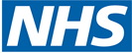
25th May 2026
Bank Holiday Opening Hours

This pharmacy will open the following hours over the May Bank Holiday weekend:

Sunday 24 May 2026 | -  -
Monday 25 May 2026 | -  -
Tuesday 26 May 2026 | -  -

Please be aware that, due to limited staff on bank holidays, waiting times may be longer or some services restricted. Thank you for your understanding and patience while we serve you.

The following pharmacies in this locality are also opening over the Bank Holiday (please telephone ahead to check):
Date | Times | Pharmacy Name | Address | Postcode | Tel Number
24th
25th
26th

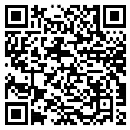
Local pharmacy details
can also be found by
scanning this code or
by visiting www.nhs.uk

Worried you have an urgent medical concern? Call 111 or visit 111.nhs.uk.
NHS 111 is available 24 hours a day, 365 days a year.
Calls are free from landlines and mobile phones.

